FUNCTION KEY - FILE

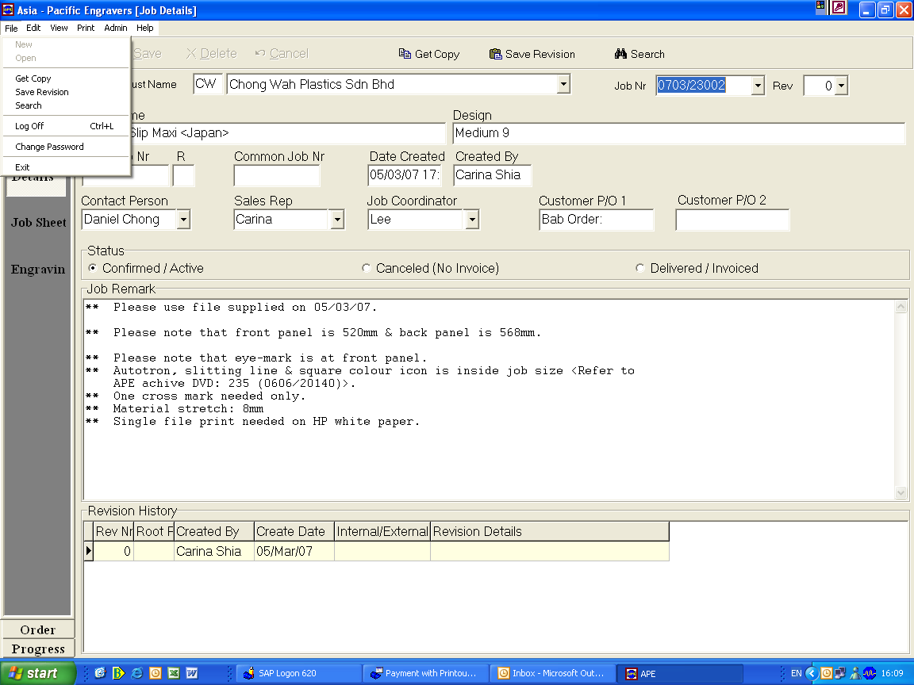

FUNCTION KEY – EDIT

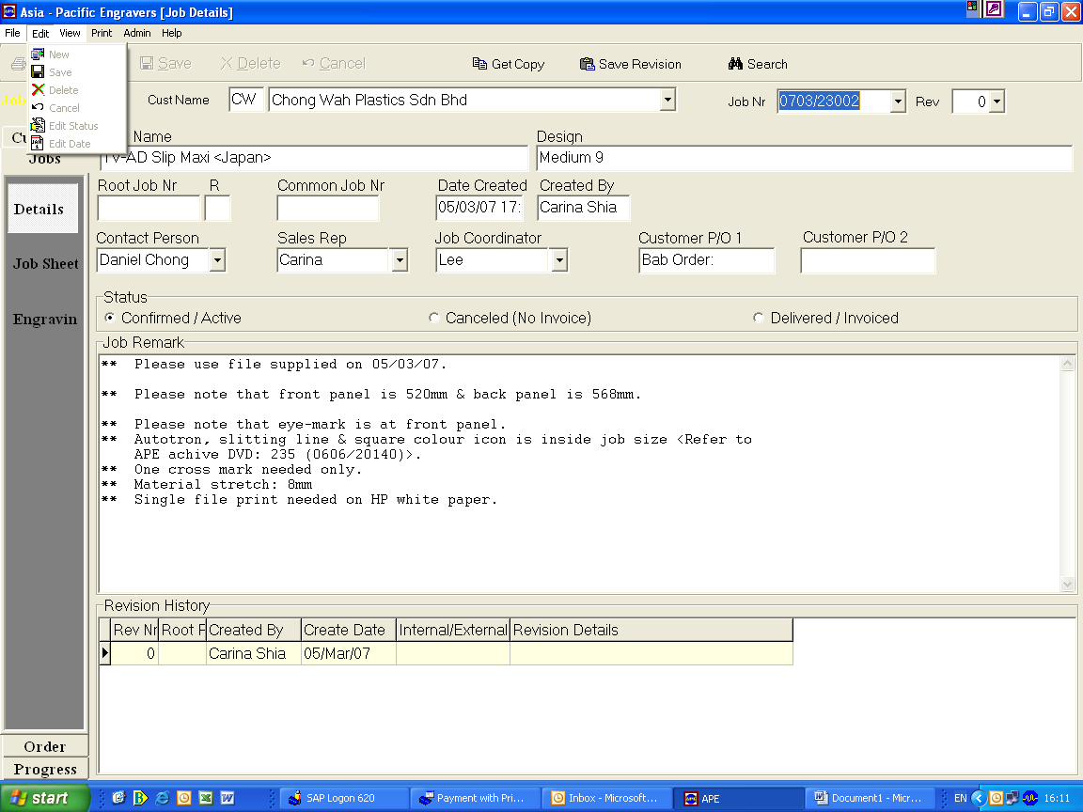

FUNCTION KEY – VIEW

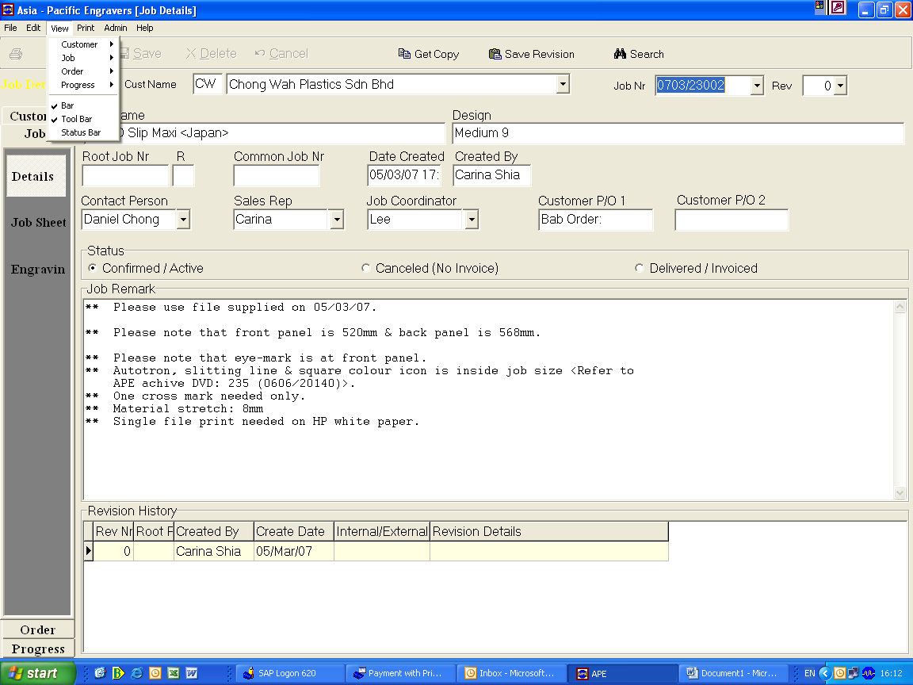

FUNCTION KEY – PRINT

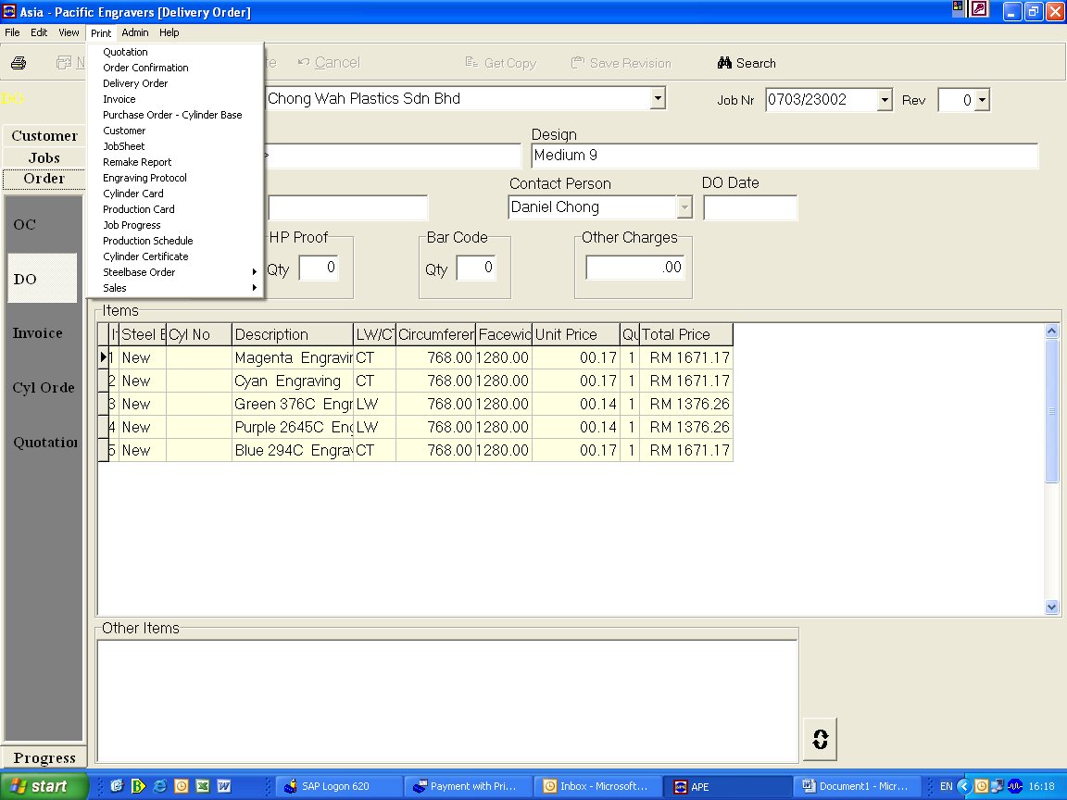

FUNCTION KEY – ADMIN

